Requirements
Version 1.0

Last reviewed: June 07, 2023
Table of Contents
1 Document Objectives and Purpose 1
2 Restrictions 1
3 Requirements 2
3.1 Data Requirements 2
4 Assumptions 2
5 Use Cases 3
5.1 Get Forecast 3
5.2 Train a Model 4
5.3 Get Available Models 4
5.4 Get Training Task State 4
5.5 Get Client Tasks 4
5.6 Get Client Trained Models 4
5.7 Get Model Details 5
5.8 View/Insert/Update Client Parameters 5
5.9 Generate Html Report 6
5.10 Authorization 6
6 Architecture High-Level Overview 6
7 Forecasting and Training Services Basic Interaction 7
7.1 Forecasting Service 7
7.1.1 Basic Flow 7
7.1.2 Messages 7
7.2 Training Model Service 7
7.2.1 Basic Flow 7
7.2.2 Messages 7

Document Objectives and Purpose
This document contains information about the requirements and decisions related with the integration of an existing application, referred to in this document as Workforce Management (WFM), and a backend that provides services to allow the use of various machine learning models and algorithms to compute (obtain) forecasts. The information in this document also serves as a reference for the development (implementation) of the backend mentioned and to establish its scope, purpose, main objectives, concerns, and responsibilities. Therefore, the main purpose of this document is to establish an initial contract between WFM and the backend to be developed.

Restrictions
R1: The backend is installed and runs in a Windows operating system environment.
R2: WFM initiates and establishes connections with the backend. The backend responds to requests, it does not initiate requests.
R3: The backend does not provide mechanisms to authenticate clients. Client authentication is performed by the WFM client application.
R4: The backend does not provide mechanisms to create and or manage security tokens used for authorization purposes.
R5: The backend and its architecture, initially, do not consider functionalities like balance loading, distributed processing, and automatic service provisioning.
R6: In this project, we do not consider the following concepts: Iterative-Incremental Development, Automation, Continuous Deployment, Versioning, Testing, and Monitoring. These concepts are commonly used in Machine Learning Operations (MLOps).

Requirements
RQ1: The integration of predictive (forecasting) capabilities provided by machine learning models with the WFM client application, according to the objectives defined in this project, should be accomplished using web services. This set of web services will also be referred to in this document as the backend.
RQ2: The WFM client application and the backend are independent applications and may run (exist) in different machines and network domains.
RQ3: The WFM client application and the backend communicate using a secure encrypted communication channel, e.g., over the HTTPS protocol, that provides secure communications, data integrity and privacy. Data is exchanged between the two applications using JSON.
RQ4: The backend should not need to know about real clients or how to access their data. The backend receives all the input data needed to provide its services, from the WFM client application in the corresponding (respective) requests.
RQ5: The backend can run (exist) in a container, virtual or physical machine, but its services and dependencies exist on a single node (machine). That is, initially, a distributed architecture is not considered (assumed).
RQ6: The backend expects and only accepts requests containing an Authorization Bearer Header valid token.
RQ7: The backend can handle multiple requests, possibly, simultaneous.
RQ8: Machine learning models are trained on sets of already collected (known) data (Offline learning, also referred to as batch or static learning). Online learning (dynamic learning) is not considered. i.e., the situation in which a model is regularly re-trained as new data becomes available, e.g., as data streams.
RQ9: An Html Report is generated as part of training a model. This report contains information about the model, that was collected during the training phase. Among other things, the Html Report contains metrics and the values of the custom parameters used to train the model and can contain images to help analyse and understand the characteristics of the model.
RQ10: The backend stores and persists information about clients, models, and training tasks.
RQ11: The backend must allow an offline installation.
RQ12: The backend will be developed (implemented) using open-source software.

Data Requirements
DR1: The backend does not have direct access to the client’s database.
DR2: The backend does not store any data it receives from a client to train a model and to obtain a forecast.
DR3: The backend does not use any data it receives from a client to perform any action other than training a model, forecasting customer flow and team size (sizing) or perform the services it provides.
DR4: The backend does not send/share any data it receives from a client to/with another party.
DR5: The backend implements data pre-processing steps to improve the quality of the data used for training.
DR6: The data used for training and forecasting should have an hourly granularity.
DR7: To improve the performance (accuracy) of the forecasts, the data used during the training phase should correspond to at least two years of previous known observations.

Assumptions
A1: Clients run the WFM client application on their systems (machines).
A2: The backend does not provide authentication and/or access control primitives and mechanisms. It is assumed that clients communicating with the backend are authenticated by an external entity, e.g., by WFM.
A3: The backend only accepts requests containing a valid authorization token. The authorization token is created (issued) and managed by an external entity, e.g., WFM.
A4: The backend runs in a single machine: this can be a physical or a virtual machine. This means that a distributed architecture/system is not assumed. Several processes (instances) can however exist, e.g., several processes running (instances of) a service can exist, on the same machine.
A5: The communication between the backend and its clients uses the HTTPS protocol. The backend runs behind a reverse proxy (or another agent) that establishes and manages HTTPS communications with the clients.
A6: There are no restrictions on the technologies and architecture used to develop the backend other than the restrictions and requirements presented in Sections 2 and 3, that apply.
A7: All clients have the same number and type of parameters which are already defined.
A8: It is assumed that a web server capable of serving images via HTTP or HTTPS is available to serve the images contained in an Html Report.

Use Cases
Figure 1 presents the main use cases considered. In Figure 1 WFM refers to the SISQUAL Workforce Management application.

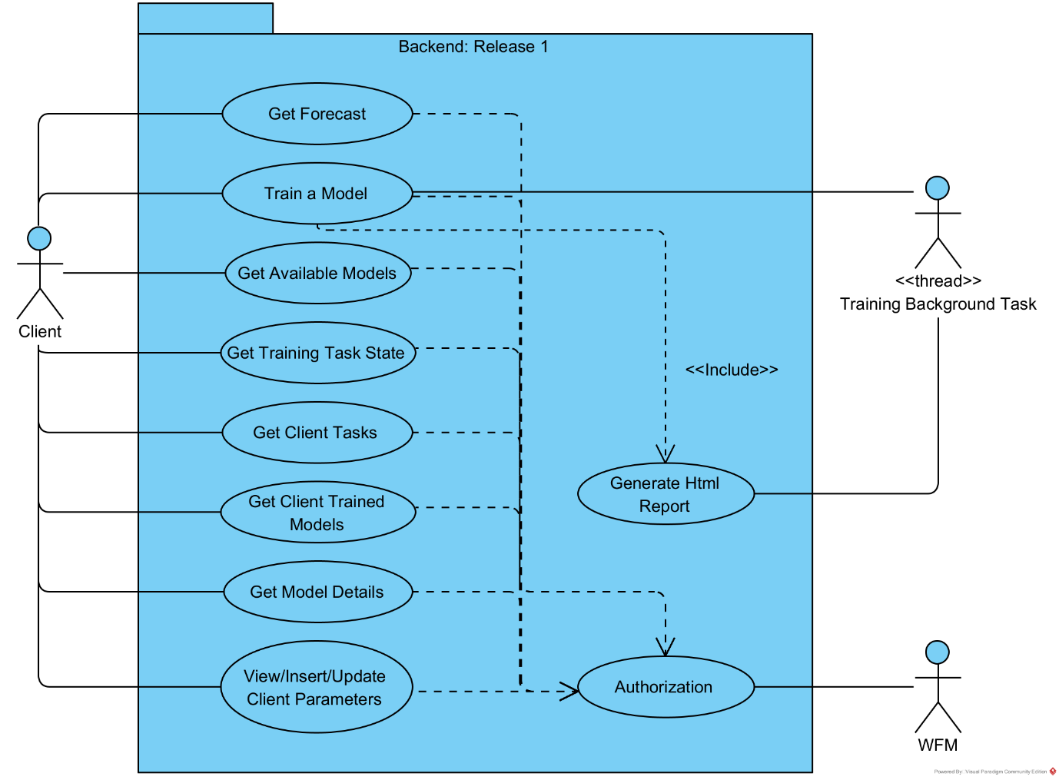
Figure 1 Main use cases.

Get Forecast
A client can use a previously trained model to obtain (get) a forecast. More details about this use case can be found in Section 7.1.

Title | Get Forecast
Primary Actor | Client
Main Flow | - In WFM, the client chooses the option to get a forecast using a trained model.  - The client specifies (enters) the input data needed to get a forecast and chooses the option to get a forecast.  - WFM sends a message to the backend requesting a forecast.  - The backend obtains the forecast and sends it to WFM.  - WFM presents the forecast to the client.

Train a Model
The backend provides a set of models that can be trained. A client can request to train a model. More details about this use case can be found in Section 7.2.

Title | Train a Model
Primary Actor | Client
Main Flow | - In WFM, the client chooses an available type of model to train.  - The client specifies the input data and the parameters needed/used for training and chooses the option to train the model.  - WFM sends a message to the backend requesting that a model of the specified type is trained using the data and the parameters sent in the message.  - The backend creates a training task and sends the task Id to WFM.  - WFM presents a message to the client indicating that the request is being processed.

Get Available Models
The backend provides a set of models for training. A client can request the list of models available for training.

Title | Get Available Models
Primary Actor | Client
Main Flow | - In WFM, the client chooses to see the list of available models for training.  - WFM sends a message to the backend requesting the list of available models for training.  - The backend sends the list requested to WFM.  - WFM presents the list of available models for training to the client.

Get Training Task State
The backend stores information about the state of a training task requested by a client. This information can be queried by the client.

Title | Get Training Task State
Primary Actor | Client
Main Flow | - In WFM, the client chooses to see the state of a training task (this can be done by specifying the task Id or by choosing a task from the list of tasks associated with the client).  - WFM sends a message to the backend requesting the state of the task.  - The backend sends the state of the corresponding task to WFM.  - WFM presents the state of the task to the client.

Get Client Tasks
The backend stores information about the tasks associated with a client. This information can be queried by the client.

Title | Get Client Tasks
Primary Actor | Client
Main Flow | - In WFM, the client chooses to see his/her list of tasks.  - WFM sends a message to the backend requesting the list of tasks associated with the client.  - The backend sends the corresponding list of tasks to WFM.  - WFM presents the list of tasks to the client.

Get Client Trained Models
The backend stores information about the models that were trained successfully. This information can be queried by a client. A client can only query and obtain information about the models that the client requested to be trained.

Title | Get Client Trained Models
Primary Actor | Client
Main Flow | - In WFM, the client chooses to see the list of trained models.  - WFM sends a message to the backend requesting the list of trained models associated with the client.  - The backend sends the corresponding list of models to WFM.  - WFM presents the list of trained models to the client.

Get Model Details
The backend stores information about the models that were trained successfully. This information can be queried by a client. A client can only query and obtain information about the models that the client requested to be trained.

Title | Get Model Details
Primary Actor | Client
Main Flow | - In WFM, the client chooses to see the list of models that the client requested to be trained.  - WFM sends a message to the backend requesting the list of trained models associated with the client.  - The backend sends the corresponding list of models to WFM.  - WFM presents the list of trained models to the client.  - The client chooses to see the details of a model shown on the list.  - WFM sends a message to the backend requesting the details of the model.  - The backend sends the details of the model to WFM.  - WFM presents the details of the model to the client.

View/Insert/Update Client Parameters
A client has a set of parameters that are stored in the backend. These parameters can be inserted, viewed, and updated.

Title | View Client Parameters
Primary Actor | Client
Main Flow | - In WFM, the client chooses to see his/her parameters stored on the backend.  - WFM sends a message to the backend requesting the client’s parameters.  - The backend sends the client’s parameters it has stored to WFM.  - WFM presents the information to the client.

Title | Insert Client Parameters
Primary Actor | Client
Main Flow | - At some point, WFM will ‘register’ a client in the backend. This process does not need client interaction. WFM sends a request to the backend to create (register) a client. The request contains the client’s parameters.  - The backend stores the client’s parameters and sends a message to WFM indicating that the client was created successfully.

Title | Update Client Parameters
Primary Actor | Client
Main Flow | - In WEM, the client chooses to update his/her parameters.  - WFM sends a request to the backend requesting the client’s parameters that it has stored.  - The backend sends the client’s parameters to WFM.  - WFM presents the parameters to the client in a way that the client can change them.  - The client changes his/her parameters and chooses the option to update them.  - WFM sends a request to the backend to update the client’s parameters. The request contains the new values for the client’s parameters.  - The backend updates the client’s parameters and sends a message to WFM indicating that the parameters were updated successfully.  - WFM show a confirmation message to the client.

Generate Html Report
An Html Report containing information about a model, is generated as part of a training model request (use case).

Title | Generate Html Report
Primary Actor | Backend
Main Flow | - The backend trains a model and collects information about the model during the training phase (this can include creating images).  - The backend creates an Html Report containing the information gathered during the training phase.  - The backend stores the Html Report in the database.

Authorization
WFM has the responsibility to authenticate clients that use the backend. The backend performs a Bearer Authentication Scheme.

Title | Authorization (Backend Side)
Primary Actor | Backend
Main Flow | - The backend receives a request from WFM.  - The backend retrieves the Bearer JWT token sent with the message.  - The token is verified.  - The token is valid.  - The backend processes the request.  - The backend sends a response to WFM. The response contains the JWT token.

Architecture High-Level Overview
Machine learning models are deployed to production (served) as web services (Microservices, Model-as-Service). Figure 2 presents a high-level overview of the backend architecture and Figure 3 presents an example of a possible deployment architecture.
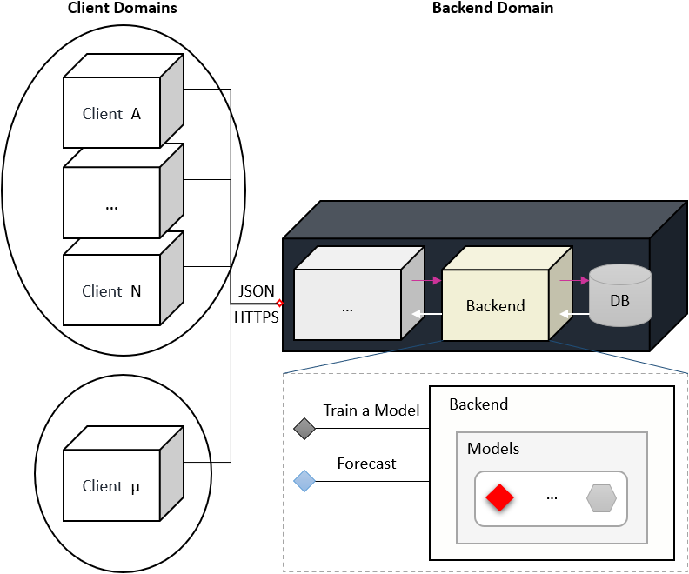
Figure 2 Backend architecture high-level overview.
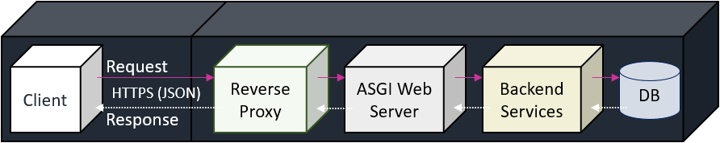
Figure 3 Example of a deployment architecture.

Forecasting and Training Services Basic Interaction

Forecasting Service

Basic Flow
- A client executes (starts) WFM. This implies that the client is authenticated (goes through an authentication process).
- In WFM, the client chooses a previously trained model from a list of trained models, specifies the input data needed by the model selected, if any, and asks for a forecast.
- WFM makes a request to the forecasting service running in the backend. The request contains an authorization token and the input data needed (required) by the model to compute (obtain) a forecast.
- The forecasting service loads the model and gets a forecast that is sent to WFM. The response includes the authorization token.
- WFM presents the forecast to the client.

Messages
Direction | Request
Message Type/Format | JSON
Content | Client Id  Model Id  Input data needed by the model to get a forecast.

Direction | Response
Message Type/Format | JSON
Content | Forecast

Training Model Service

Basic Flow
- A client executes (starts) WFM. This implies that the client is authenticated (goes through an authentication process).
- In WFM, the client asks to train a new model.
- WFM presents a list of available models for training.
  - WFM has a list of available models.
  - WFM does not have a list of available models, WFM makes a request to the backend to get a list of available models for training. The backend sends the list of available models.
- The client selects a model for training and specifies the input data needed. WFM makes a request to the training model service running in the backend. The request contains an authorization token an all the input data needed (required) to train the model.
- The backend creates a task to train the model and sends the task id to WFM.
- WFM presents a message to the client informing that the training task was created.
- In WFM, the client can follow the state of the training task by refreshing his/her list of tasks or his/her list of trained models.
- The client refreshes his/her list of trained models, and the new trained model appears in the list. The client can see a report containing information about the model.

Messages
Direction | Request
Message Type/Format | JSON
Content | Client Id  Model Type  Input data needed to train the model.

Direction | Response
Message Type/Format | JSON
Content | Task Id

https://ml-ops.org
Retraining and monitoring model accuracy decay were not considered.
The previous 4 steps correspond to the Get Client Trained Models use case.

